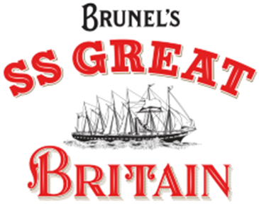

Work Experience, 30 June – 4 July 2025
SS Great Britain

Many thanks for your interest in the Work Experience Programme at the SS Great Britain. We want to offer young people who might be interested in a career in Heritage and Museums, a weeklong experience, working with a range of different teams. These sessions will take place over five days from 10am to 3pm (with breaks and lunch).

Who is it for: We’re interested to hear from Bristol-based Year 10 students who want to learn more about careers in Heritage and Museums. You don’t need any previous experience, just some passion and interest in the sector and if you want to ‘have a go’, that’s good enough for us. We are particularly interested to hear from students in receipt of free school meals or who do not have any connections / familial ties to the Heritage and Museum industries. We also recognise the museum industries are majority white, cisgender and non-disabled. We believe our work will be stronger with greater diversity and welcome applications from those who bring difference.

Brunel’s SS Great Britain

The SS Great Britain is the world’s first great ocean liner and the most innovative steam ship of her time. The ship was built in Bristol and launched in 1843, travelling to New York and later taking passengers over to Australia during the Gold Rush.

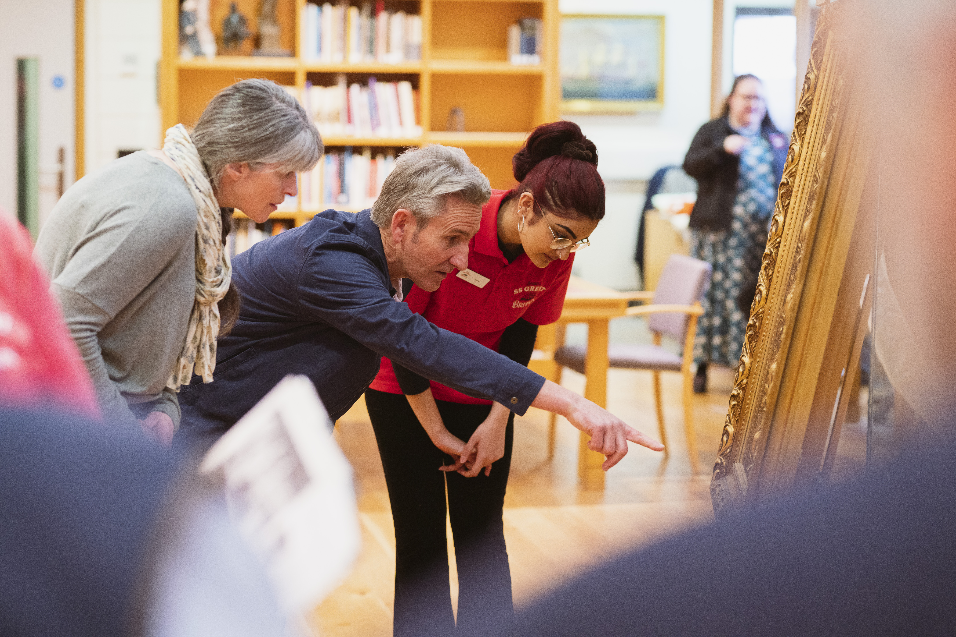

Today we are an award-winning museum in the centre of Bristol www.ssgreatbritain.org.
We are also Bristol’s no. 1 visitor attraction (according to TripAdvisor). Visitors can travel back in time and explore the ship as she was in the Victorian era (including sights, sounds and smells!) They can also find out more about the passengers who travelled on board the ship. We also have a library and archive (collection of important historical objects). We have a national museum Being Brunel, which explores the life and works of Isambard Kingdom Brunel.

You will have the opportunity to explore what goes in to delivering a world-class visitor experience. How do we attract new people to visit the ship? How do we market our events to people in Bristol, the UK and all over the world? What makes a great half-term activity for families? What stories about passengers and crew can we discover in our library which will be interesting for younger visitors?

The Work Experience week

We have put together a week which will give you experience working across the organisation. In addition to exploring what it’s like to work in a museum and visitor attraction, you will gain experience with other teams such as marketing, museum interpretation and conservation. You will find out what different people do in their jobs every day (and see if any of these roles appeal to you), complete team challenges and have the opportunity to contribute your ideas.

You will be working in a team of 6 students who will be part of our work experience programme this year.

A few examples of activities you might be doing are:

- A behind the scenes tour of the ship with our interpretation team, learning about how the sound system, interactives and even smells work!
- A workshop and group challenge with our marketing team.
- Researching passenger stories in our archive and library.
- Trying out and evaluating our resources for school visits

About you

- You might already be interested in history, tourism, or the arts.
- You might want to explore what working in a museum, or visitor attraction is like.
- You might enjoy planning events, coming up with new ideas or communicating with other people.
- You might want to explore a range of different jobs and see which ones appeal to you.

To apply, please complete and return the attached application form to:

Volunteering
The SS Great Britain Trust,
The Great Western Dockyard,
Bristol,
BS1 6TY

Or email: volunteering@ssgreatbritain.org

Work Experience Application Form

Please fill in all parts so we can consider you for a place. If you prefer, please answer the questions and record your responses using an audio file and send this to us.

Remember, we are looking for passion and interest, more than experience.

CONTACT DETAILS
Name
Your school

ABOUT YOU
What do you know already about Brunel’s SS Great Britain?

Please let us know if you have visited us before.

Why would you like to do a work experience placement at the SS Great Britain?
What do you hope to get out of the week?

What skills, qualities and interests would you bring to the SS Great Britain team?

Please return this form to:
Volunteering@ssgreatbritain.org

