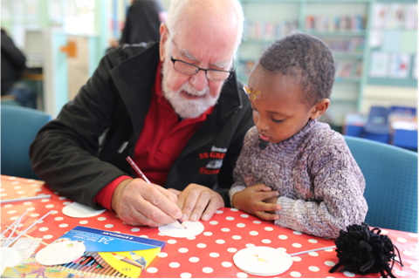

Museums belong to everyone. There is a strong body of evidence that arts and culture are powerful ways to connect people together and increase wellbeing.

From our data, we know that many communities don’t engage with SS Great Britain. The ship’s story is primarily one of migration, but we know that the stories we tell currently do not represent the diversity of heritage connected with it.

We have an opportunity to work with communities in Bristol to contribute to a city which is more connected, happier and healthier. Our collections give us all an amazing opportunity to research and share the history of the many people connected to the SS Great Britain and the life and work of Isambard Kingdom Brunel – people from all walks of life and with heritage from many parts of the world.

We know that meaningful change is led by communities themselves. In our community work we focus on building realtionships and looking for opportunities to work together, sharing our assets and resources, led by the interests and aspirations of communities.

We prioritise our work around national and local statistics of disadvantage, but we connect with communities who have a shared identity of place or interest, or who come together around a common need. We have limited the number of communities we are working with so we have time to get to know people, form networks of contacts to find the best ways to can support communities, and can accommodate their needs and explore their interests. We hope to work with other communities in the future.

For 2024, we are working with groups whose members or service users are:

• Residents of Hartcliffe, Knowle West, Southmead, Barton Hill and Avonmouth.

• Disabled people (using the social model of disability)

• From cultural groups representing heritages outside Western Europe

• Refugees and asylum seekers

**Community Engagement Volunteers** support our work to connect with communities and work together.

**Main activities:**

In this role you can work alongside staff, other volunteers and community partners at festivals, community spaces, clubs, youth groups and libraries to meet people from different backgrounds, help to deliver activities sharing the stories of SS Great Britain, and find out about people’s interests and needs.

You’ll can also welcome community groups to SS Great Britain, and support activities around the dockyard, on the ship, in the library, museums and education spaces.

You can engage both adults and children in fun and interactive ways using handling objects, crafts, games, trails and dressing up, encouraging participation and conversation. You can also assist in the practicalities of each event, including setting up and packing away.

You can support projects to facilitate community groups to work with our stories and collections to create things for themselves and wider communities.

As part of the team, you will be invited to be join shared planning and evaluation with communities.

You will be part of a team of around 20 communities volunteers and work with the Communities Officer and other members of staff depending on the activity.

**What the SS Great Britain can offer you:**

* A fun and varied role as part of a friendly and supportive team of volunteers and staff
* A chance to develop skills and experience in participation and community engagement work in a museum setting
* The chance to explore the history of the ship and the work and life of Isambard Kingdom Brunel – including spending time on board the ship and working with handling collections.
* Comprehensive induction and training programme, support from our Communities Officer, settling in and annual reviews to help with your development
* A reference when you have been volunteering with us for over six months, with a minimum of 12 hours’ volunteering
* Opportunities to meet and work with other volunteers, staff and partner organisations
* Discount in the SS Great Britain shop and café
* Travel expenses incurred by volunteering – please discuss your needs with us

**About you:**

This is an interesting and varied role, with the opportunity to volunteer with communities from a wide varity of backgrounds and in different settings. It’s also a flexible role, allowing you to choose the events you are able to support, perhaps focussing on particular communities.

These take place on both weekdays and weekends, and in holidays and school term time. If you have fixed commitments around work, caring or study, we will try our best to accommodate these.

There are many types of people who can bring skills and experience to this role. You may have previously worked with community groups, families or children, or in an education, cultural or heritage setting. You may have professional or lived experience you would like to share or new skills you would like to develop.

Above all, we are looking for people who:

* Enjoy engaging with people of all ages, including families and children
* Are flexible and enjoy learning new things
* Have a friendly and collaborative approach
* Enjoy supporting and enabling other people
* Are able to commit to at least 6 months volunteering

We welcome interest in volunteering from people of all backgrounds. We will discuss your individual needs and ensure volunteering opportunities are accessible for you.

**Interested?**

If you would like to join our team or have any questions, please get in touch.

If you are able, we’d ask you to fill out an application form, available at <https://www.ssgreatbritain.org/support-us/volunteering/>

You can contact our volunteer team by emailing [volunteering@ssgreatbritain.org](mailto:volunteering@ssgreatbritain.org) or call 0117 374 4502. We would love to hear from you!

You will be invited to a Taster event where you’ll have the chance to learn more about the volunteer roles, meet the team, look around, ask any questions you have and ensure that it is right for you. You are welcome to bring a friend or family member with you.

**Thanks for your interest in being part of our team!**

Updated October 2024