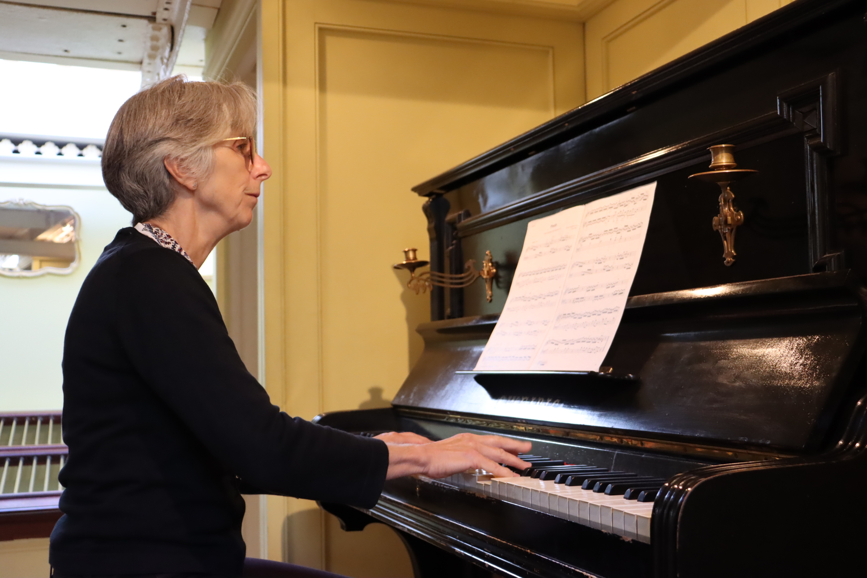
Pianist Role Description
Purpose of the role:
To recreate the musical atmosphere in 1st class, on board Brunel’s ss Great Britain.

Main activities:
- Our volunteer pianists play authentic Victorian music on the Promenade Deck of the Ship, as passengers would have done during many of her voyages.
- Helping to source appropriate pieces to play, in consultation with the staff team. The Ship’s working life was between the 1840s and 1880s, therefore music should either be of this period or earlier.
- Helping visitors explore the ship and answering their questions.

What the ss Great Britain can offer:

- The chance to learn the fascinating history of the ship and the work and life of Isambard Kingdom Brunel.
- A social and training programme, with opportunities and events throughout the year.
- Behind the scenes access to the collections.
- The chance to make new friends and to be part of a vibrant team.
- A reference when you have been volunteering with us regularly for over six months.

About You:

No prior historical knowledge is required as we will provide you with a full induction to the ship. We are looking for people who:
- Have a competent level of skill playing the piano and Victorian music
- The ability to perform confidently in front of groups of people
- Are friendly, approachable and confident in a busy environment
- Have an interest in Victorian and maritime history
- Are willing to undertake training related to the role
- Have an enthusiasm for working with our visitors of all ages and backgrounds
- Are able to volunteer for a morning or afternoon session per week.

As a Volunteer Pianist you will be supervised by Sarah O’Brien, Visitor Experience Supervisor.
Volunteers are an important part of the organisation and play a vital role in enhancing the work of the Trust. We are committed to providing volunteering opportunities of a high standard.
Ready to take the next step?
If you would like to join our crew or have any questions please get in touch by emailing volunteering@ssgreatbritain.org or telephoning 0117 462 3167 (Tues-Fri). We would love to hear from you!

You will be invited to a recruitment event where you’ll have the chance to learn more about the volunteer roles, meet the team, discuss the role further and ensure that it is right for you.

