Transcript over a letter published in the St Helena Advocate on Monday 27 September 1852

Fore Saloon Great Britain
Sept. 1st 1852.

To J. H. Cox, Esq.
Dear Sir,

We, the undersigned, passengers in the fore-saloon of the Great Britain, be respectfully to lay before you a statement of grievances under which we have suffered, and are now suffering.

We engaged our berths with the understanding that the catering and attendance for that part of the ship would be fit for any gentleman – the printed circular of the owners having stated that a good substantial table would be provided; this we had a right to expect from the large amount of money we have paid; that such has not been the case you may judge from the following facts: -

1st. The insufficiency of the food placed on the table for dinner especially, is such, that no one can take their meals comfortably, and that in fact on that account there occurs daily a scrambling eagerness for preference.

2nd. The quality of the food is such, that often hunger will not force the passengers to partake of it. We also have much reason to complain of the quality of the tea and coffee supplied, they being of a cheap description, astringent and disagreeable to the taste; nor does the raw sugar without milk tend to render them more palatable.

3rd. The attendance is of the worst possible description with regard to numbers, there not being nearly the requisite number of stewards for so large a body of persons. A want of cleanliness is a natural consequence of this, and we very seriously complain of the filthy state in which plates, knives, forks, &c, are placed upon the table.

4th. In trifling matters, we complain of the parsimony which pervades the entire arrangements, and which, while it proves of little pecuniary advantage to the owners, is productive of much discomfort to the passengers, such as a scant supply of towels, soap &c.

5th. The condition of the water-closets has been such as to be, in this warm weather, most liable to create and foster disease, besides being most offensive.

In making these complaints, we would also respectfully state, that the scale of provisions furnished to us by the owners, has not been complied with, and we would beg your most serious attention to redress our ills.

With the courtesy show us by Capt. Matthews and his officers, we are in every respect satisfied. We particularly feel grateful to you as having charge over this saloon for your great civility and exertion on our behalf.

We remain your obedient servants,
(signed) A. W. Critchley
H. C. Stavely
John A. Edwards
EWD. James Pocock
W. J. Smith
Committee
And 80 passengers of fore-saloon.
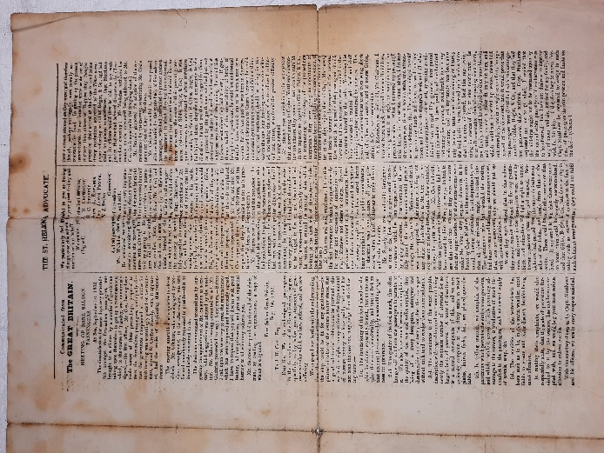

Images taken from The St Helena Advocate: BRSGB2011.0984 – courtesy of The SS Great Britain Trust

