Article from The Illustrated London News on 28 August 1852.

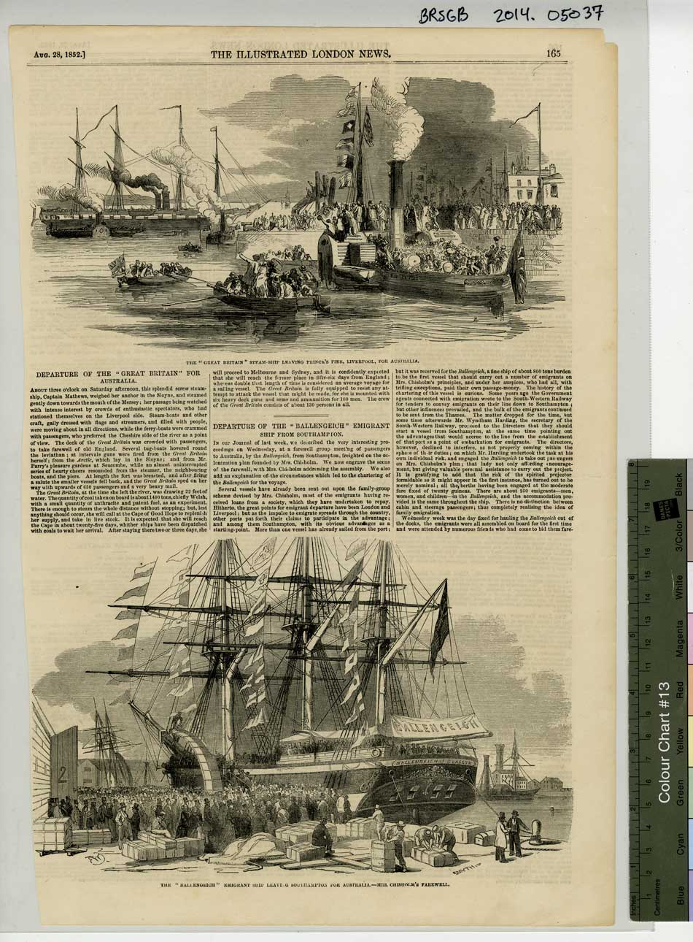BRSGB 2014.05037 – Courtesy of the SS Great Britain Trust

Transcript of the article from The Illustrated London News on 28 August 1852.

Departure of the “Great Britain” for Australia.

About three o’clock on Saturday afternoon, this splendid screw steam-ship, Captain Mathews, weighed her anchor in the Sloyne, and steamed gently down towards the mouth of the Mersey; her passage being watched with intense interest by crowds of enthusiastic spectators, who had stationed themselves on the Liverpool side. Steam-boats and other craft, gaily dressed with flags and streamers, and filled with people, were moving about in all directions, while the ferry-boats were crammed with passengers, who preferred the Cheshire side of the river as a point of view. The deck of the Great Britain was crowded with passengers to take farewell of old England. Several tug-boats hovered around the leviathan; at intervals guns were fired from the Great Britain herself; from the Arctic, which lay in the Sloyne; and from Mr. Parry’s pleasure gardens at Seacombe, while an almost uninterrupted series of hearty cheers resounded from the steamer, the neighbouring boats, and piers. At length the fort was breasted, and after firing a salute the smaller vessels fell back, and the Great Britain sped on her way with upwards of 630 passengers and a very heavy mail.

The Great Britain, at the time she left the river, was drawing 22 feet of water. The quantity of coal taken on board is about 1400 tons, chiefly Welsh, with a small quantity of anthracite and patent fuel, as an experiment. There is enough to steam the whole distance without stopping; but, lest anything should occur, she will call at the Cape of Good Hope to replenish her supply, and take in live stock. It is expected that she will reach the Cape in about twenty-five days, whither ship have been dispatched with coals to wait her arrival. After staying there two or three days, she will proceed to Melbourne and Sydney, and it is confidently expected that she will reach the former place in fifty-six days from England; whereas double that length of time is considered an average voyage for a sailing vessel. The Great Britain is fully equipped to resist any attempt to attack the vessel that might be made, for she is mounted with six heavy deck guns and arms and ammunition for 100 men. The crew of the Great Britain consists of about 130 persons in all.

